Revit Make Local File Procedure

- Create the central file following the standard procedures. (Refer to RSA Revit Manual.)
- Copy the following files on the same folder where the central file is located.
- Logo.jog
- Revit make Local .exe
- Settings.ini
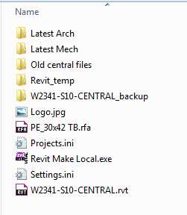

- The Settings.ini file needs to be updated for every project. Please refer to the image to see the changes made to this file.

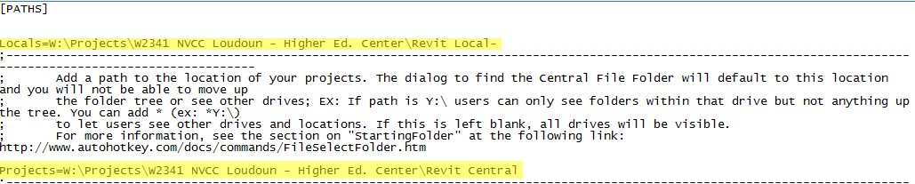

- Click on "Go to Central File Folder" and navigate to the Central File Folder. Click
Ok.

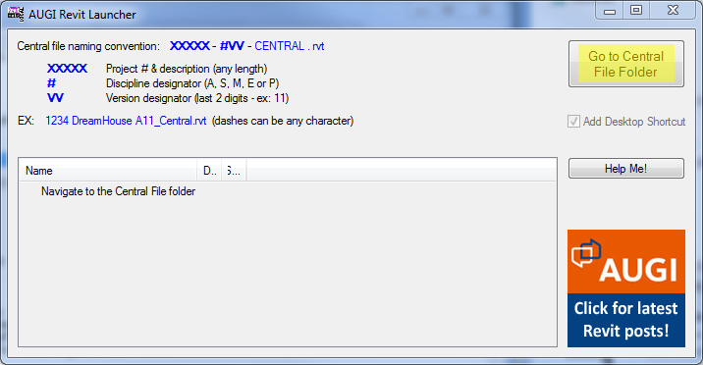

- The list box will show any number of files in the chosen folder named according to the convention below:

  - XXXXX-#VV-central.rvt, where:

  - XXXXX can be anything of any length # is the discipline (A, S or MEP, where the 3 letters in MEP can be expressed in any order)
  - VV is the Revit version number
  - The dashes can be any character.
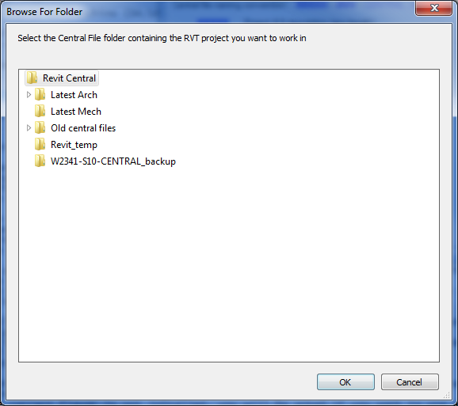
- Right click on one of the central files and pick from the following: Create Local & Open; Create Local & Specify Worksets to open; Open a Detached Local copy.
Notice the bolded entry; that is the default option which can be invoked by simply
double clicking a central file (the default can be changed in settings.ini).

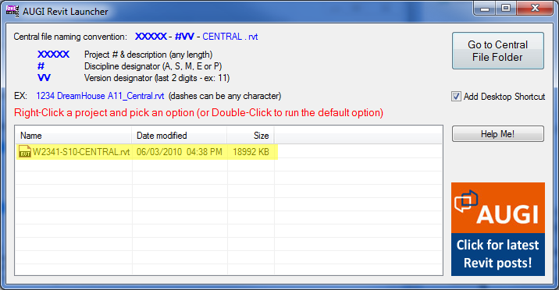

- By default, a unique shortcut is created on your desktop with a suffix showing what that shortcut will do next time it is invoked
- If Revit is not open, a new Revit session will be launched and the local file is opened. The Revit "flavor" is determined from the file naming
- Regular user will be following procedure 5 thru 8.

